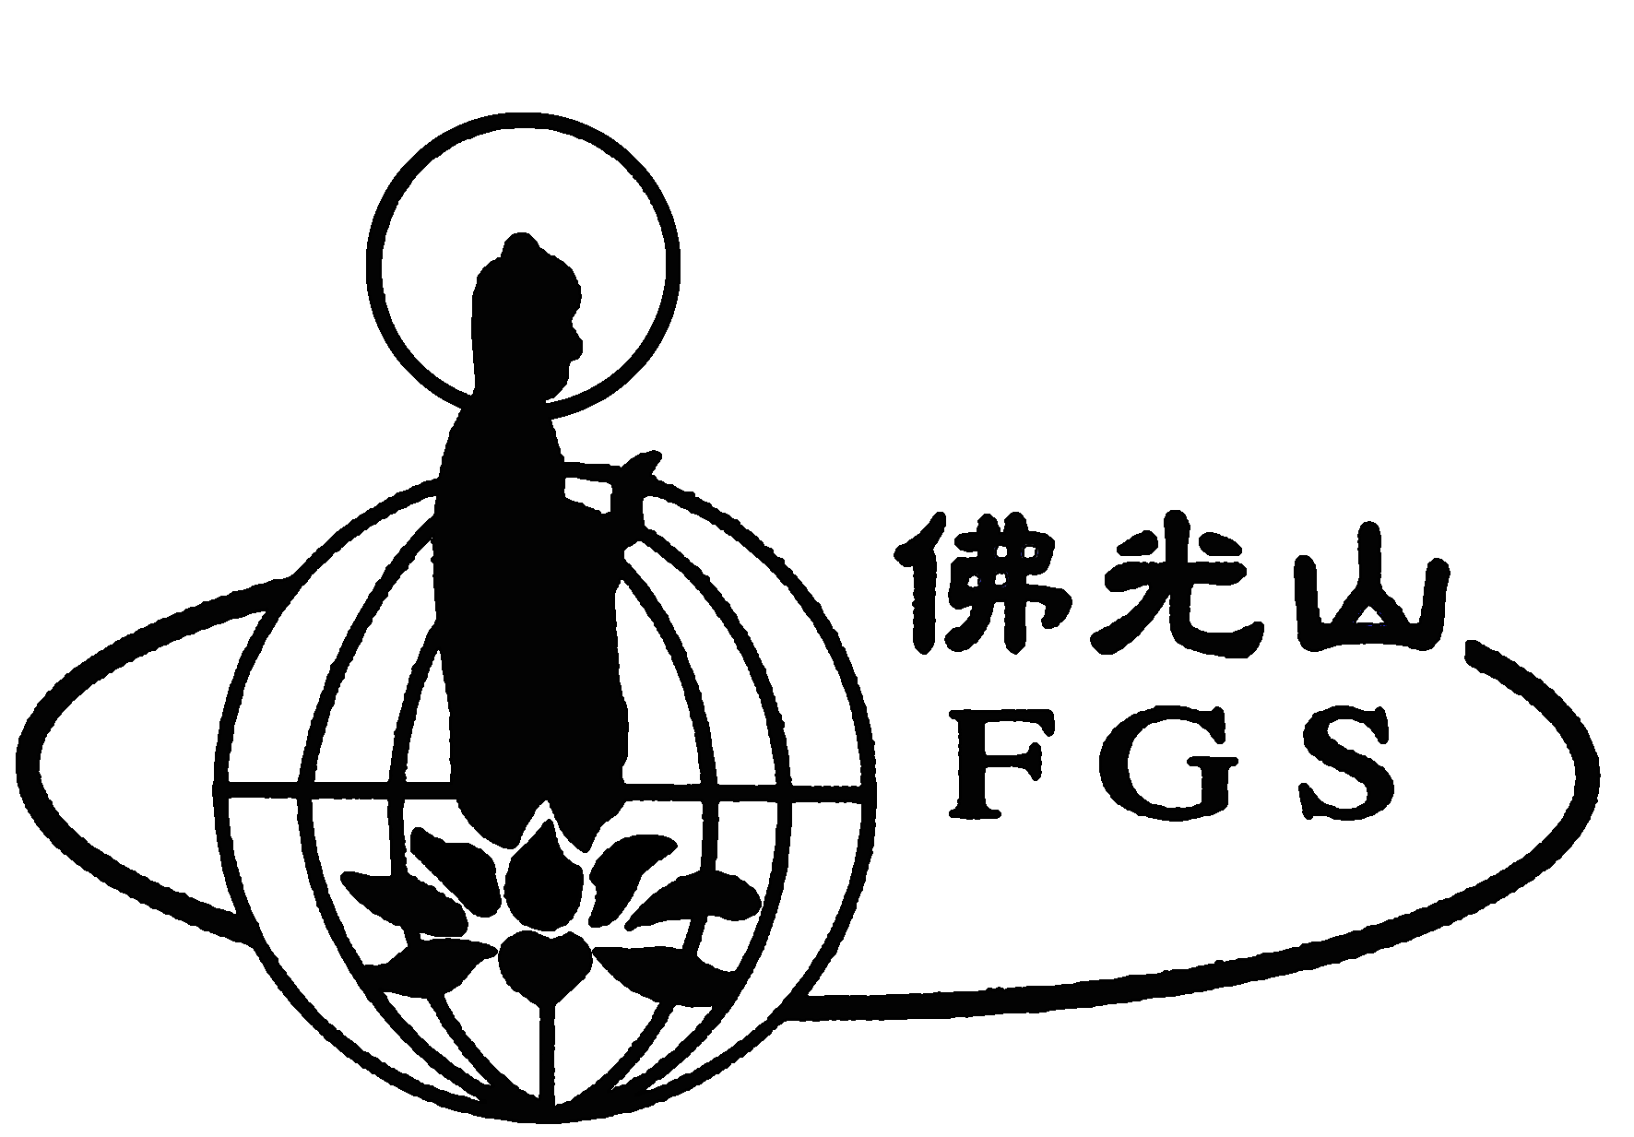
Fo Guang Shan Melbourne

Chinese New Year Memorial Service

Dear Devotees:
Chinese new year is the time for us to pay our respect and honor and to express our heartfelt gratitude to our ancestors. The temple will conduct a special Dharma Ceremony on Sunday, 30th Jan., chanting sutras and mantras for the benefit of our ancestors and all sentient beings as well for those whom we are indebted to or have offended. This ceremony will provide an opportunity for them to move on to a better life. You and your entire family are welcome to participate. We wish you peace and joy.

Location | Date and content | Tel. & Address
Fo Guang Shan Melbourne | Jan 30, 2011 (Sun) 9.30am  Ksitigarbha Sutra, Offering | 89 Somerville Rd. Yarraville 3013  Tel:9314 5147 Fax:9314 2006  www.ibcv.org.au

- If you wish to set up Blessing Name Plates for Commemorate Plates for the
deceased, please make prior registration at the Temple’s Reception.
- Discretional donation to meal offering for making good affinities with people
is welcome.

Donations: Large: $50 / Medium: $30/ Small: Free donation
Please make cheque out to I.B.C.V.
Please use the form below to indicate donation(s)

"------------------------------------------------------------------------------
If more than one person, please write in another piece of paper.

Person to whom merit being transferred:
Your name:
Your relation to person about:
Donation:
Address:
Date: Handled By:

